**MAJORS BASEBALL SKILLS CHALLENGES**

How are your baseball skills?! We’ve designed challenges you can do at home to see what skills you know how to do and to help you know what to improve on! Can you complete them all? If you are up for the challenge, complete the activities below, write your results, and return the completed form to the recreation department to receive your baseball prize!

Note: Many of the drills will say to use an object. You can use cones, water bottles, t-shirts, boxes, or whatever else your parents say is okay! Distances and skills are different for different ages.

**Warming up is crucial** to prepare your body for self-practice and prevent injuries. Here are two warm-up drills you can do at home before starting the baseball drills to improve your pitching, batting, and catching skills:

**Jogging:** Start by jogging in place or around your practice area for 5-10 minutes. This will increase your heart rate and warm up your muscles.

**Arm circles:** Stand with your feet shoulder-width apart and your arms extended to the sides. Move your arms in circular motions, first clockwise and then counterclockwise. This will help loosen up your shoulder muscles and improve your arm mobility.

By doing these warm-up exercises, you can increase blood flow to your muscles, reduce the risk of injuries, and prepare your body for a productive self-practice session.

**These challenges are meant to challenge, stretch and improve your skills as a baseball player! They are meant to be difficult. If you can’t get a challenge down, that’s okay! Keep trying and have fun with it!**

**Throwing:** (For this you will need a ball, Glove and a partner) Here is a video of a great throwing technique: <https://www.youtube.com/watch?v=zrr7OwTJnXY>

___Level 1: Rocking Throw Drill. <https://www.youtube.com/watch?v=v7yG6s20Vo4> Complete this 10 times @ 10-15 feet away.

___Level 2: Lawn Mower Throwing Drill. <https://www.youtube.com/watch?v=sKWOL8rt5-Q> Complete 10 of these @ 30 Feet.

___Level 3: The Sing-Shuffle Drill: <https://www.youtube.com/watch?v=2Wec98Z2U38> Complete 10 Throws @ 55-90 Ft. (Move Back Slowly)

**Baseball Throwing Technique video:**<https://www.youtube.com/watch?v=BomXCfnLl7Q>

**Batting:** (This drill you will need a bat. If you have a tee available you can use it or if you do not you can pretend a ball is there.)

___Level 1: Half Turns-Start with the bat pinned up against your back leg, that would be the right leg for righty hitters, and left leg for the lefties. Take your stride into the launch position, keeping the bat pinned to our back leg. Rotate your lower half to the point of contact while keeping the bat pinned to your body. The point of contact is where you have your belly button facing the pitcher. An important part of this drill is that we do not want to “squish the bug”, or having our back foot anchored to the ground. We want to drive off our back leg and generate power. (Complete 20 of these)

___Level 2: The See Saw Drill- This is really one of the first and most important movements in the swing. If this part of the swing is off, then the rest of the swing will also be off. By establishing muscle memory in the early movement of the swing, it allows the hitter to be short to the point of contact. Point the knob of the bat towards where the catcher’s feet would be. Move the knob of the bat towards the pitcher while taking a short stride. (Complete 20 of these)

__Level 3: The Bat Path Drill- To start this drill, start in the launch position, so the stride has been taken and we’re ready to launch. This is where the See Saw Drill immediately plays into effect. When striding into launch position, the knob of the bat should be pointed at the catcher's feet, ready to explode towards the pitcher.

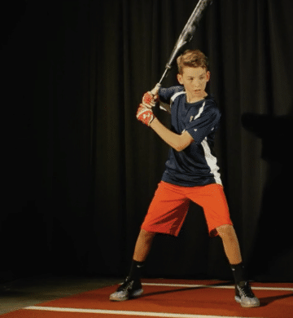

The hitter here has the knob of the bat working towards the catcher’s feet and a good launch position, with her front foot at about 40-45 degrees and heel in the air. As the left heel hits the ground, we use what we learned in the see-saw drill, pointing the knob of the bat towards the pitcher. This drill really emphasizes rhythm and the bat path. Now that you have established a solid launch position and began on a good bat path, you pause to feel this position. After a short pause, you will integrate the lower half of your body from the half turns drill you practiced earlier and finish our swing. Hit the ball off the tee. Every time you complete this make sure you are following the correct procedures to clean up any posture issues. (Complete this 15 times.)

**Base Running:** (If you don’t have a bases, set up four objects to make your own field set up and try to run and touch each item)

___Level 1: Run with Contact Drill: Hustle after making contact with the ball at the plate and always run through the orange bag at first except if the are going to round the base and head for second. Even if it is a foul ball you need to make the effort to run no matter what. Coaches at first base will tell you if the ball is a foul, if you should run through the base or if you should advance to 2nd. Get into the habit of dropping the bat and running.(Complete this drill 12 times)

___Level 2: Follow the Pitcher: For this drill you can start at 1st, 2nd, or 3rd base. Have a friend or parent pretend to be a pitcher and toss the ball across home plate. You will want to lean back as the pitcher leans back and push off the base when the ball leaves her hand. Get ⅓ of the way to the other base, pause and finish your run towards the next base. (Complete this 15 Times)

___Level 3: Sliding Drill- You usually want to start with just sitting in place and ensuring that you understand the proper form. The bent leg should be under the extended leg, creating a figure 4. Whichever leg is extended and should feel natural to you. You should keep your hands off the ground*, and lean your weight back off your legs slightly. Once you have the feel of the sliding form, you can move to sliding at half speed, and then at full speed when comfortable. (Complete this 15 Times)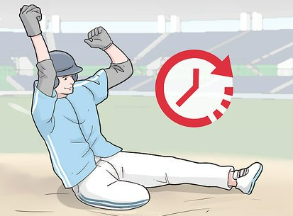

**Field Grounding:** (If you don't have a partner to roll to you then grab a tennis ball and roll it towards a wall. The tennis ball will bounce back to you. This will allow you to practice this skill)

___Level 1: Understanding the basics of good grounding technique. <https://www.youtube.com/watch?v=wmR1rRfUL4g> (Start at the 0:55 Mark) Follow through on each of these drills in the video 15 times each.

___Level 2: Place yourself in the 2nd base position. Have a friend or parent either hit a ball or throw a grounder towards you. Make sure to follow through with the grounding technique in the video above. When you have received the ball make sure to throw towards first base. (Complete this 15 times.)

___Level 3: For this next level follow the directions from level 2 but place yourself at shortstop position and throw towards 1st base again. (Complete this 15 times.)

**Sportsmanship:**

Watch this video and read the paragraph below and write down how you can be a good sport this season with your soccer team:



Sportsmanship: In NLC Rec, we want to encourage good sportsmanship. We are “Focused on Fun & Family Recreation”. We want everyone to try their hardest while being kind. You can choose to have fun whether you win or lose the game!

You can do that by being nice to yourself and others. Focus on doing your best! If you make a mistake, don’t give up. Have a positive attitude and keep trying! If your teammate makes a mistake, don’t get mad at them. Encourage them to keep trying! If your opponent makes a mistake, don’t make fun of them. Tell them “good game” or “it was fun playing against you.”

How will you be a good sport this baseball season?

________________________________________________________________________________________________________________________________________________________________________________________________________________________________________________________________________________________